**7.1.1: Measures initiated by the Institution for the promotion of gender equity during the last five years.**

Annual gender sensitization action plan

**INDEX**

|  |  |  |
| --- | --- | --- |
| **S.No** | **Details** | **Page No** |
| 1 | Gender Sensitization Lab | 2 |
| 2 | Anti-Drug Awareness program | 9 |
| 3 | Tree Plantation Program | 12 |
| 4 | Blood Donation Camp | 13 |
| 5 | Self-defense and Karate program | 14 |
| 6 | She Team | 17 |
| 7 | Yoga | 18 |
| 8 | Sports | 20 |
| 9 | Rangoli Competitions | 23 |
| 10 | Women Welfare Committee | 25 |
| 11 | Technical Symposium | 27 |
| 12 | International women’s Day | 28 |
| 13 | Annual Gender Sensitization Action Plan for last five years | 30 |

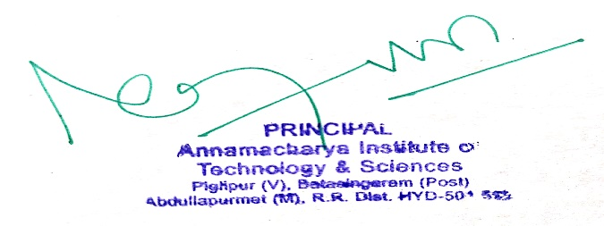PRINCIPAL

**7.1.1 Number of gender equity promotion programs organized by the institution year-wise during the last five years**.

AITH has set gender equity as one of its goal. The following are the gender equity promotion programs organized as follows.

**1. Gender Sensitization Lab:**

R18 B.TECH. CSE

# *MC309/*MC409: GENDER SENSITIZATION LAB

**(An Activity-based Course)**

# B.TECH II Year II Sem. L T P C

**0 0 2 0**

# COURSE DESCRIPTION

This course offers an introduction to Gender Studies, an interdisciplinary field that asks critical questions about the meanings of sex and gender in society. The primary goal of this course is to familiarize students with key issues, questions and debates in Gender Studies, both historical and contemporary. It draws on multiple disciplines – such as literature, history, economics, psychology, sociology, philosophy, political science, anthropology and media studies – to examine cultural assumptions about sex, gender, and sexuality.

This course integrates analysis of current events through student presentations, aiming to increase awareness of contemporary and historical experiences of women, and of the multiple ways that sex and gender interact with race, class, caste, nationality and other social identities. This course also seeks to build an understanding and initiate and strengthen programmes combating gender- based violence and discrimination. The course also features several exercises and reflective activities designed to examine the concepts of gender, gender-based violence, sexuality, and rights. It will further explore the impact of gender-based violence on education, health and development.

# Objectives of the Course:

* To develop students’ sensibility with regard to issues of gender in contemporary India.
* 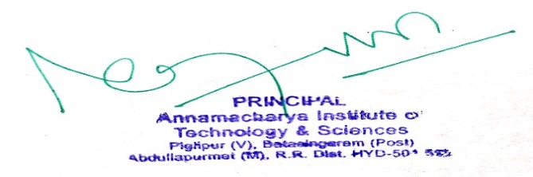To provide a critical perspective on the socialization of men and women.
* To introduce students to information about some key biological aspects of genders.
* To expose the students to debates on the politics and economics of work.
* To help students reflect critically on gender violence.
* To expose students to more egalitarian interactions between men and women.

# Learning Outcomes:

* Students will have developed a better understanding of important issues related to gender in contemporary India.
* Students will be sensitized to basic dimensions of the biological, sociological, psychological and legal aspects of gender. This will be achieved through discussion of materials derived from research, facts, everyday life, literature and film.
* Students will attain a finer grasp of how gender discrimination works in our society and how to counter it.
* Students will acquire insight into the gendered division of labour and its relation to politics and economics.
* Men and women students and professionals will be better equipped to work and live together as equals.
* Students will develop a sense of appreciation of women in all walks of life.
* Through providing accounts of studies and movements as well as the new laws that provide protection and relief to women, the textbook will empower students to understand and respond to gender violence.

# UNIT - I: UNDERSTANDING GENDER

Introduction: Definition of Gender-Basic Gender Concepts and Terminology-Exploring Attitudes towards Gender-Construction of Gender-Socialization: Making Women, Making Men- Preparing for Womanhood. Growing up Male. First lessons in Caste.

# UNIT – II: GENDER ROLES AND RELATIONS

Two or Many? -Struggles with Discrimination-Gender Roles and Relations-Types of Gender Roles- Gender Roles and Relationships Matrix-Missing Women-Sex Selection and Its Consequences- Declining Sex Ratio. Demographic Consequences-Gender Spectrum: Beyond the Binary

# UNIT – III: GENDER AND LABOUR

Division and Valuation of Labour-Housework: The Invisible Labor- “My Mother doesn’t Work.” “Share the Load.”-Work: Its Politics and Economics -Fact and Fiction. Unrecognized and Unaccounted work.

-Gender Development Issues-Gender, Governance and Sustainable Development-Gender and Human Rights-Gender and Mainstreaming

# UNIT – IV: GENDER - BASED VIOLENCE

The Concept of Violence- Types of Gender-based Violence-Gender-based Violence from a Human Rights Perspective-Sexual Harassment: Say No! -Sexual Harassment, not Eve-teasing- Coping with Everyday Harassment- Further Reading: “*Chupulu”.*

Domestic Violence: Speaking OutIs Home a Safe Place? -When Women Unite [Film]. Rebuilding Lives. Thinking about Sexual Violence Blaming the Victim-“I Fought for my Life….”

# UNIT – V: GENDER AND CULTURE

Gender and Film-Gender and Electronic Media-Gender and Advertisement-Gender and Popular Literature- Gender Development Issues-Gender Issues-Gender Sensitive Language-Gender and Popular Literature - Just Relationships: Being Together as Equals

Mary Kom and Onler. Love and Acid just do not Mix. Love Letters. Mothers and Fathers. Rosa Parks- The Brave Heart.

# Note: Since it is Interdisciplinary Course, Resource Persons can be drawn from the fields of English Literature or Sociology or Political Science or any other qualified faculty who has expertise in this field from engineering departments.

* *Classes will consist of a combination of activities: dialogue-based lectures, discussions, collaborative learning activities, group work and in-class assignments. Apart from the above prescribed book, Teachers can make use of any authentic materials related to the topics given in the syllabus on “Gender”.*
* **ESSENTIAL READING**: The Textbook, “*Towards a World of Equals: A Bilingual Textbook on Gender” written* by A.Suneetha, Uma Bhrugubanda, DuggiralaVasanta, Rama Melkote, Vasudha Nagaraj, Asma Rasheed, Gogu Shyamala, Deepa Sreenivas and Susie Tharu published by Telugu Akademi, Telangana Government in 2015.

# ASSESSMENT AND GRADING:

* Discussion & Classroom Participation: 20%
* Project/Assignment: 30%
* End Term Exam: 50%

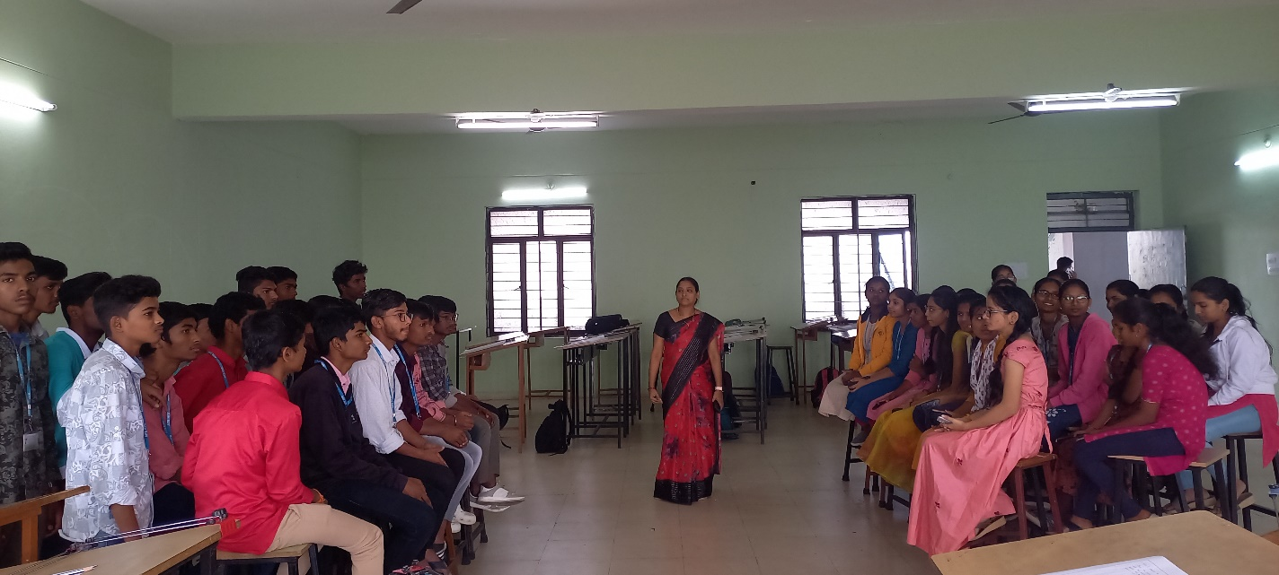

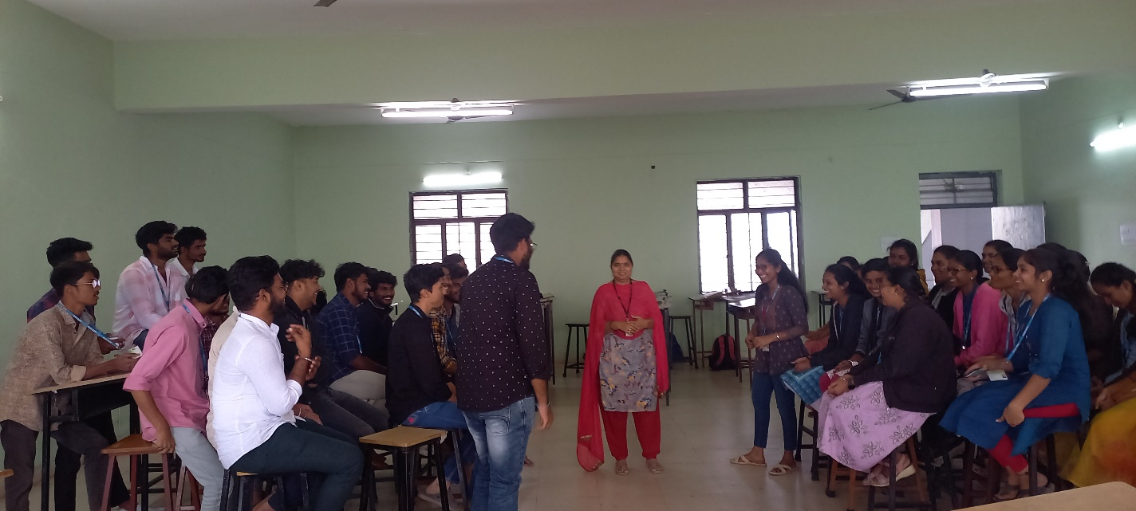

**DEBATE ON GENDER EQUUITY (Gender equity is the process of being fair to women and men).**



**1.1. Gender Sensitization Lab: R22 B.TECH. CSE**

# *MC209: GENDER SENSITIZATION LAB

**(An Activity-based Course)**

**JNTU Hyderabad**

**B.Tech. II Year I Sem.**  **L T P C**

**0 0 2 0**

**COURSE DESCRIPTION:**

This course offers an introduction to Gender Studies, an interdisciplinary field that asks critical questions about the meanings of sex and gender in society. The primary goal of this course is to familiarize students with key issues, questions and debates in Gender Studies, both historical and contemporary. It draws on multiple disciplines – such as literature, history, economics, psychology, sociology, philosophy, political science, anthropology and media studies – to examine cultural assumptions about sex, gender, and sexuality.

This course integrates analysis of current events through student presentations, aiming to increase awareness of contemporary and historical experiences of women, and of the multiple ways that sex and gender interact with race, class, caste, nationality and other social identities. This course also seeks to build an understanding and initiate and strengthen programmes combating gender-based violence and discrimination. The course also features several exercises and reflective activities designed to examine the concepts of gender, gender-based violence, sexuality, and rights. It will further explore the impact of gender-based violence on education, health and development.

**Objectives of the Course**

• To develop students’ sensibility with regard to issues of gender in contemporary India.

• To provide a critical perspective on the socialization of men and women.

• To introduce students to information about some key biological aspects of genders.

• To expose the students to debates on the politics and economics of work.

• To help students reflect critically on gender violence.

• To expose students to more egalitarian interactions between men and women.

**Learning Outcomes**

* Students will have developed a better understanding of important issues related to gender in contemporary India.
* Students will be sensitized to basic dimensions of the biological, sociological, psychological and legal aspects of gender. This will be achieved through discussion of materials derived from research, facts, everyday life, literature and film.
* Students will attain a finer grasp of how gender discrimination works in our society and how to counter it.
* Students will acquire insight into the gendered division of labor and its relation to politics and economics.
* Men and women students and professionals will be better equipped to work and live together as equals.
* Students will develop a sense of appreciation of women in all walks of life.
* Through providing accounts of studies and movements as well as the new laws that provide protection and relief to women, the textbook will empower students to understand and respond to gender violence.

**Unit-I: UNDERSTANDING GENDE**

Introduction: Definition of Gender-Basic Gender Concepts and Terminology-Exploring Attitudes towards Gender-Construction of Gender-Socialization: Making Women, Making Men - Preparing for Womanhood. Growing up Male. First lessons in Caste.

**Unit – II: GENDER ROLES AND RELATIONS**

Two or Many? -Struggles with Discrimination-Gender Roles and Relations-Types of Gender RolesGender Roles and Relationships Matrix-Missing Women-Sex Selection and Its ConsequencesDeclining Sex Ratio. Demographic Consequences-Gender Spectrum: Beyond the Binary

**Unit – III: GENDER AND LABOUR**

Division and Valuation of Labour-Housework: The Invisible Labor- “My Mother doesn’t Work.” “Share the Load.”-Work: Its Politics and Economics -Fact and Fiction. Unrecognized and Unaccounted work. -Gender Development Issues-Gender, Governance and Sustainable Development-Gender and Human Rights-Gender and Mainstreaming

**Unit – IV: GENDER - BASED VIOLENCE**

The Concept of Violence- Types of Gender-based Violence-Gender-based Violence from a Human Rights Perspective-Sexual Harassment: Say No!-Sexual Harassment, not Eve-teasing- Coping with Everyday Harassment- Further Reading: “Chupulu”.

Domestic Violence: Speaking OutIs Home a Safe Place? -When Women Unite [Film]. Rebuilding Lives. Thinking about Sexual Violence Blaming the Victim-“I Fought for my Life….”

**Unit – V: GENDER AND CULTURE**

 Gender and Film-Gender and Electronic Media-Gender and Advertisement-Gender and Popular Literature- Gender Development Issues-Gender Issues-Gender Sensitive Language-Gender and Popular Literature - Just Relationships: Being Together as Equals Mary Kom and Onler. Love and Acid just do not Mix. Love Letters. Mothers and Fathers. Rosa Parks The Brave Heart.

Note: Since it is Interdisciplinary Course, Resource Persons can be drawn from the fields of English Literature or Sociology or Political Science or any other qualified faculty who has expertise in this field from engineering departments.

* Classes will consist of a combination of activities: dialogue-based lectures, discussions, collaborative learning activities, group work and in-class assignments. Apart from the above prescribed book, Teachers can make use of any authentic materials related to the topics given in the syllabus on “Gender”.
* ESSENTIAL READING: The Textbook, “Towards a World of Equals: A Bilingual Textbook on Gender” written by A.Suneetha, Uma Bhrugubanda, DuggiralaVasanta, Rama Melkote, Vasudha Nagaraj, Asma Rasheed, Gogu Shyamala, Deepa Sreenivas and Susie Tharu published by Telugu Akademi, Telangana Government in 2015.

**ASSESSMENT AND GRADING:**

• Discussion & Classroom Participation: 20%

• Project/Assignment: 30%

• End Term Exam: 50%

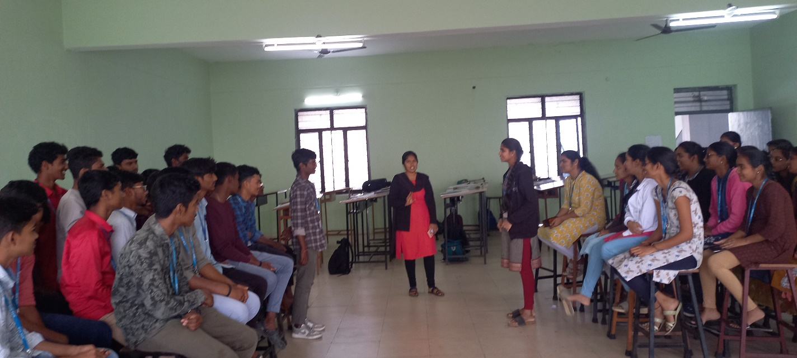

**DEBATE ON GENDER EQUUITY (Gender equity is the process of being fair to women and men).**

PRINCIPAL

## **2. Anti-Drug Awareness Program:**

Annamacharya Institute of Technology & Sciences, Hyderabad-National Service Scheme (AITSH-NSS) unit cell collaborated with Hima humanitarian association jointly organized by Anti-Drug Awareness Program in college premises.

Hima humanitarian association a social welfare organization focusing on the problems and issues faced by society and contributing service to Anti-Drug Awareness Program campaign car rally to visit colleges and explain the students the hazards and problems faced by consuming drugs through distribution of pamphlets and make a pledge by students against drugs.

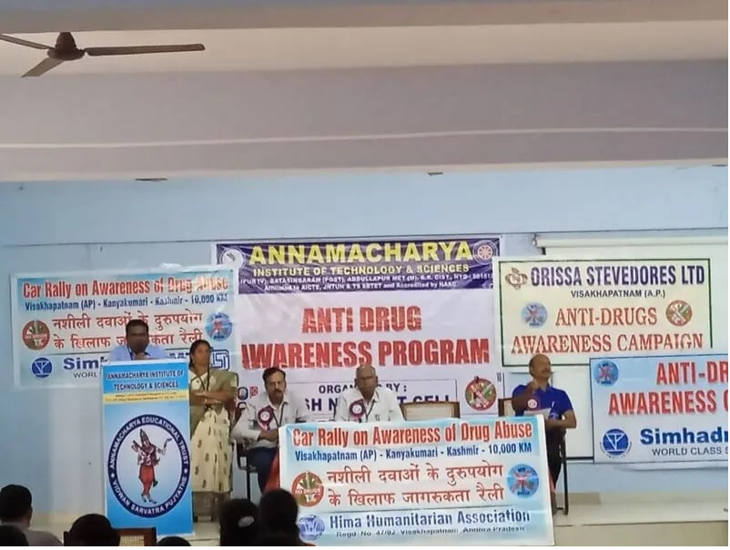 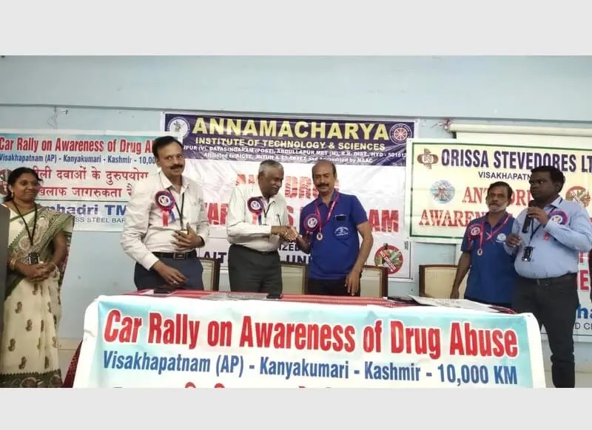



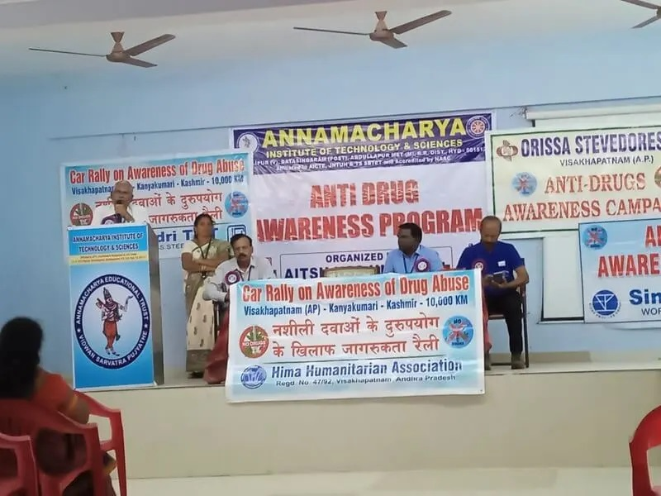

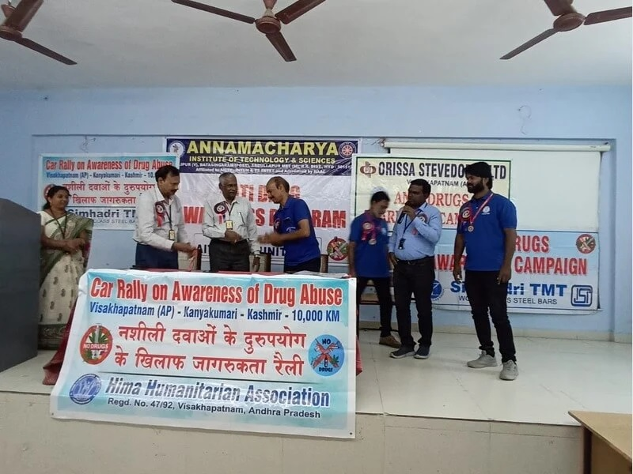

**Anti-Drug Awareness program conducted on 14th December’ 2023 at AITH.**

PRINCIPAL

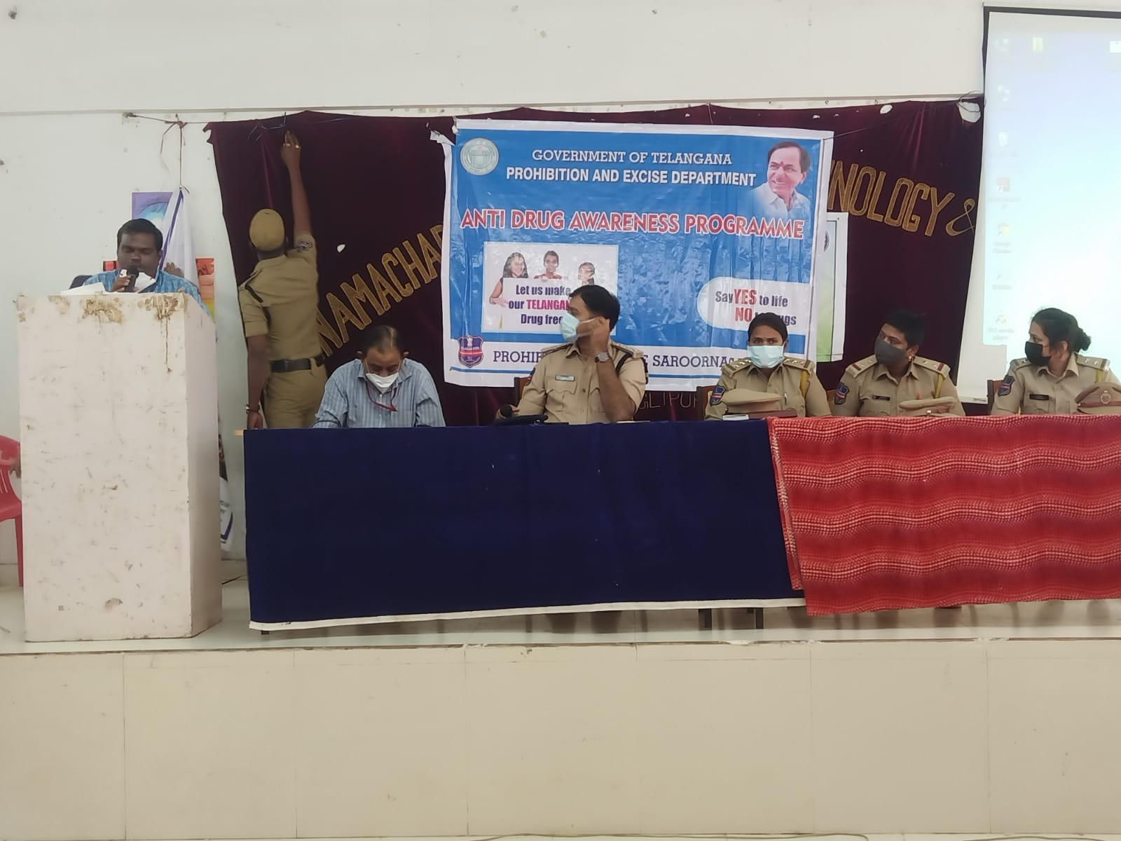

**Anti-Drug Awareness program by Govt. of Telangana**

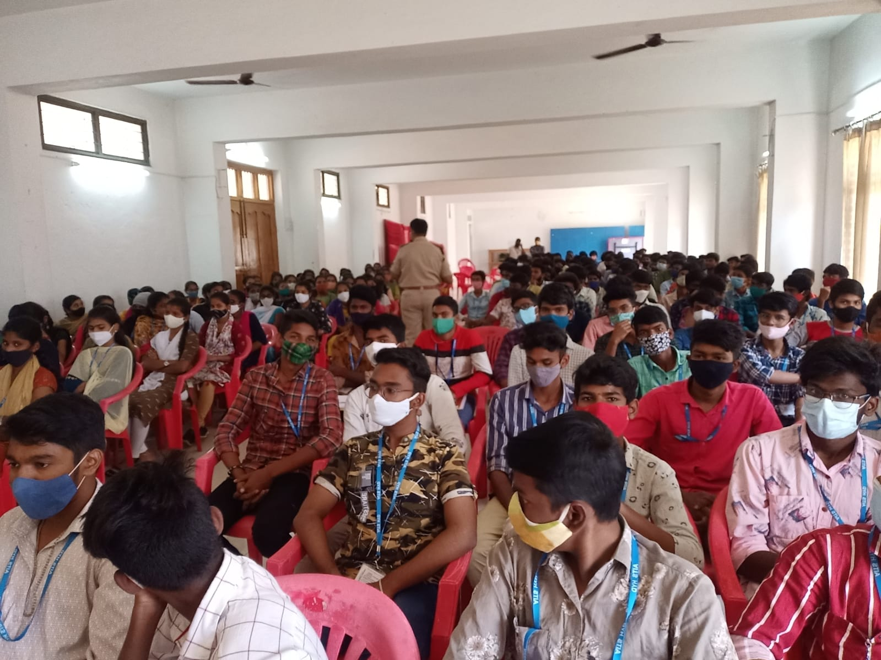

**Anti-Drug Awareness program conducted on 10th October’ 2022 at AITH.**

PRINCIPAL

**3. Tree Plantation Program:**

AITS organized a Haritha Haram Program in the institute premises on October 25th, 2019 at 10:00 a.m. The staff and students along with NSS volunteers participated in this program. The students displayed the placards a rally and to create awareness among the students on the importance of Haritha Haram. The students and staff identified appropriate place for plantation of plants and prepared it for plantation. As a part of it the students have planted 120 trees in the campus. They also made the identification cards of the plants and students also committed themselves to nourish and maintain the allocated plant.

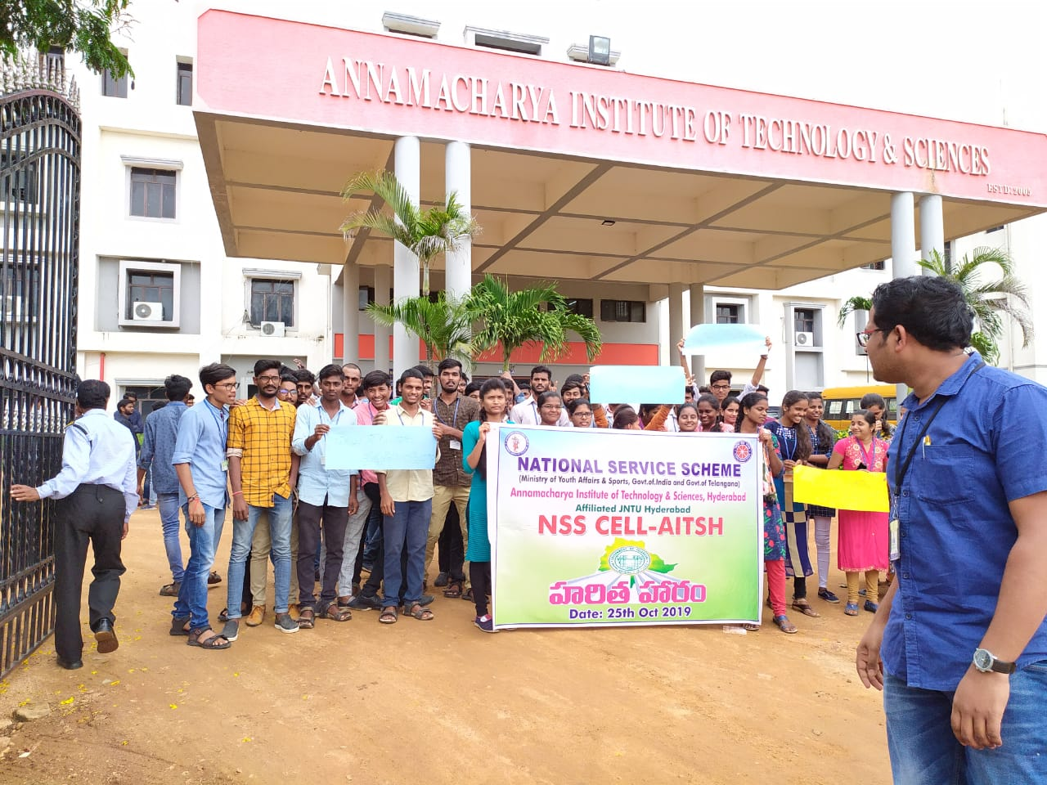

**Tree planation program performed by students at AITH**

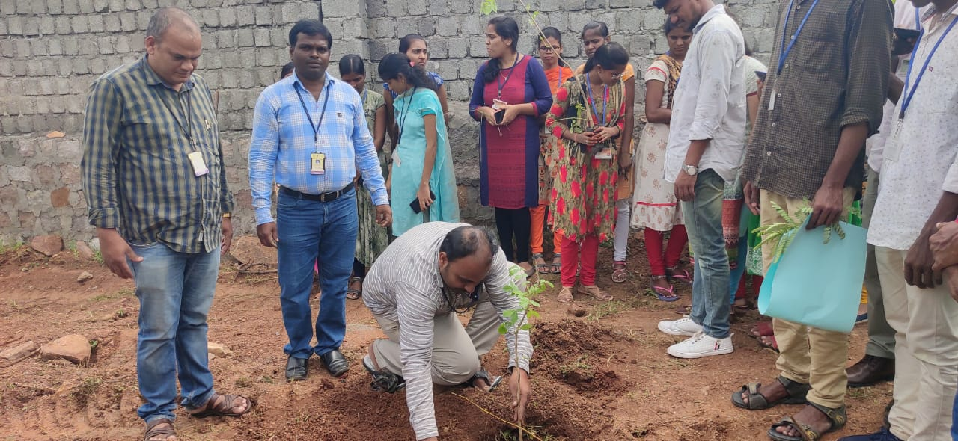

**Tree planation done by Staff at AITH**

PRINCIPAL

**4. Blood Donation Camp:**

AITS was organized a blood donation camp in the institution in association with Shri. P V Narsimha Rao Memorial Trust to motivate people to donate blood and social works. The purpose of blood donation camp to select a suitable donor whose blood will be safe to the recipient and who himself shall not in any way be harmed by blood donation.

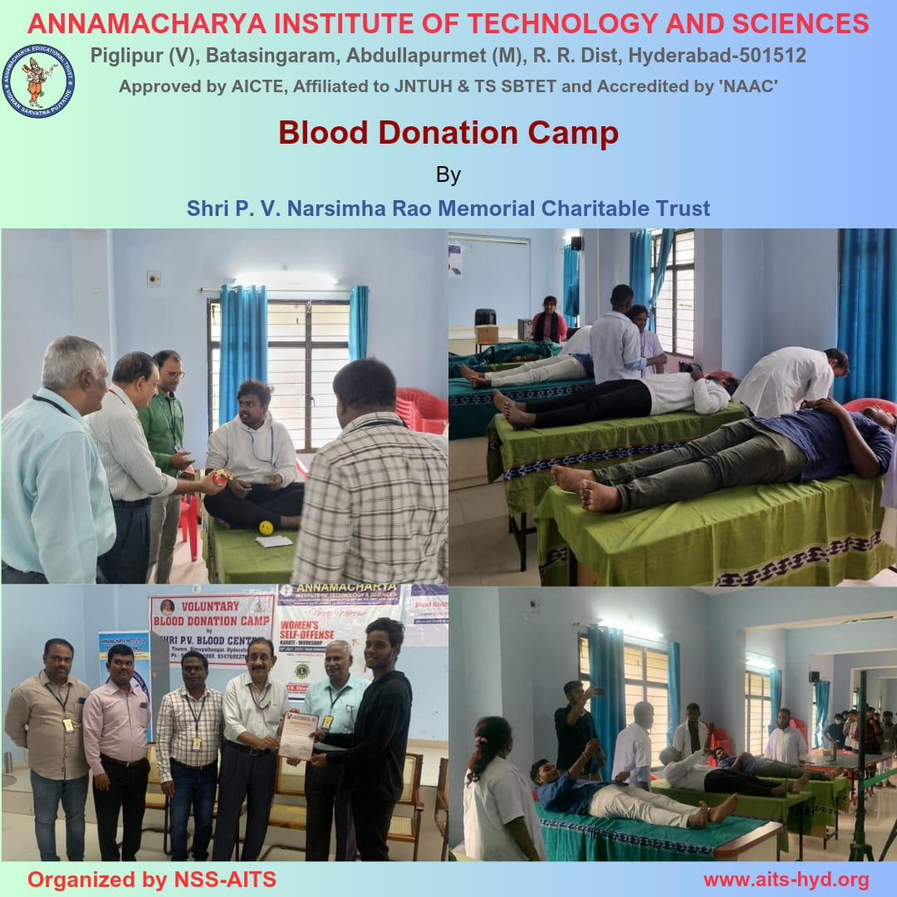

**Blood Donation Camp conducted on 19th July’ 2023 at AITH.**



**5. Self-defense and Karate Program:**

In these days and ages, self-defense is one of the utmost important things. Children are now getting abused and violated as they don’t have that vulnerability and ability to fight back. Self Defense is the act of defending oneself, one's property or someone else from physical harm. Self-Defense is the method by which one can protect oneself with one’s own strength. It involves various techniques but the first step towards it is Fitness. Learning self-defense through fitness is of prime importance as there are tremendous power imbalance and unsafety where we live today. Self Defense has an important role in the life of women. This also tends to break the stereotype about women. Self Defense is a skill which every woman should acquire to make their own and others live safer on a daily basis or whenever the situation requires.

To attain and empower the students AITH conducting Karate workshop every year.

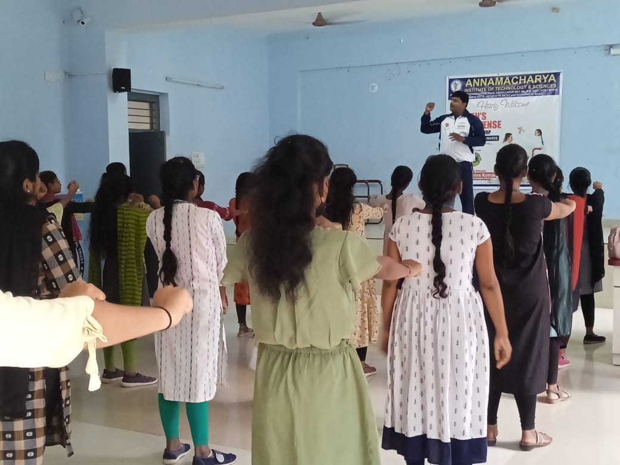

**Self-Defense and Karate training program to train girl students for self-defense organized at AITH.**

PRINCIPAL

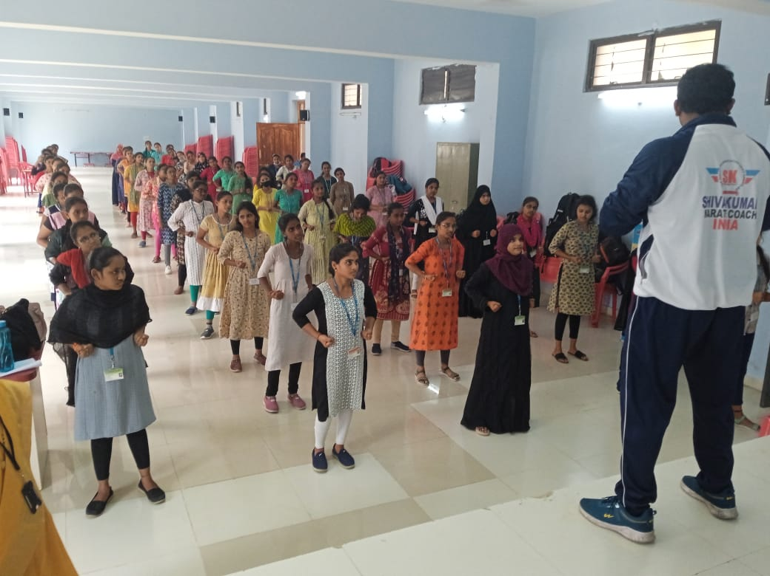 **Karate practice performed by girl students**

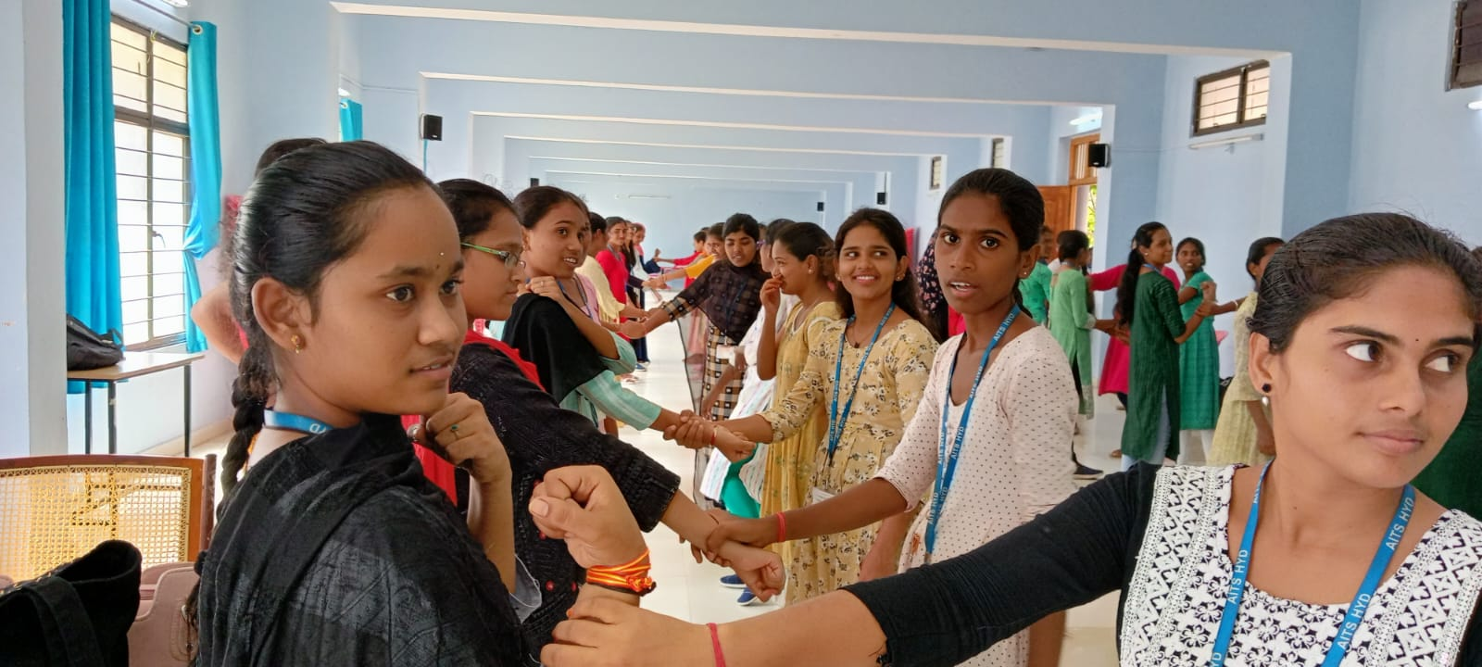

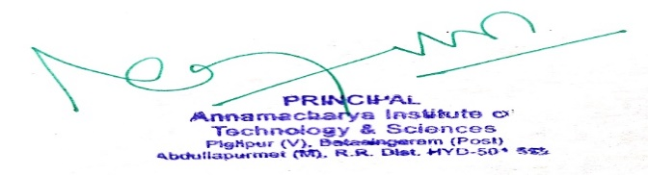**Self-Defense and Karate performed by girl students**

PRINCIPAL

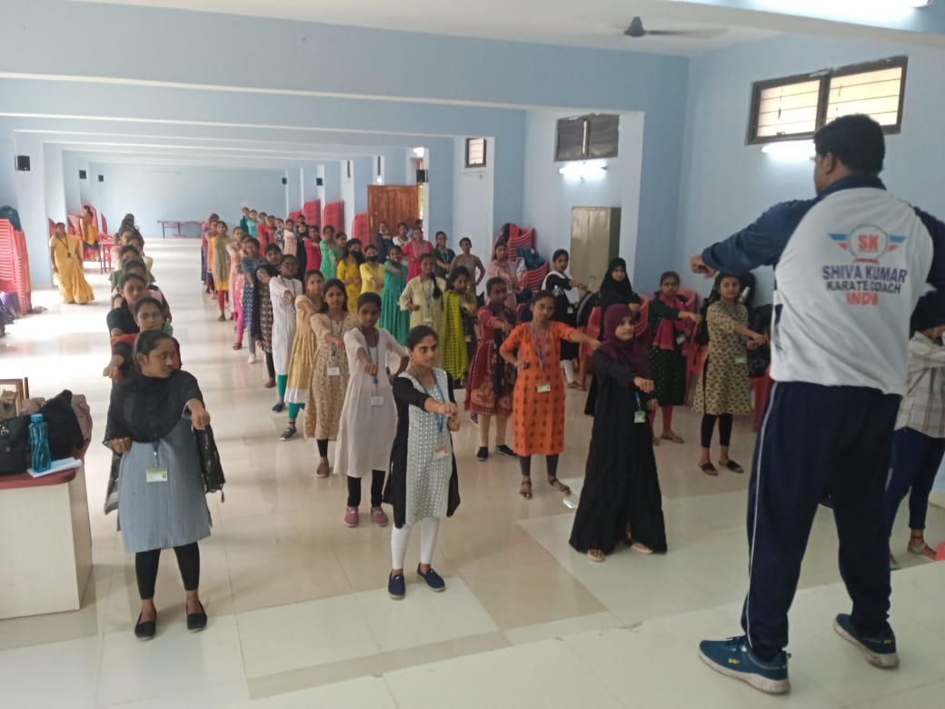**Self-Defense and Karate performed by girl students**

**Self-Defense and Karate performed by girl students under the guidance of Karate Coach**

**Mr. Shiva Kumar, Karate Coach.**

**6. She Team**

SHE Teams is a division of Telangana Police for enhanced safety and security of women. They also work to prevent child marriages in Telangana State. The teams work in small groups to arrest eve teasers, stalkers and harassers. AITH invited she team personals and conducted awareness program about women safety.

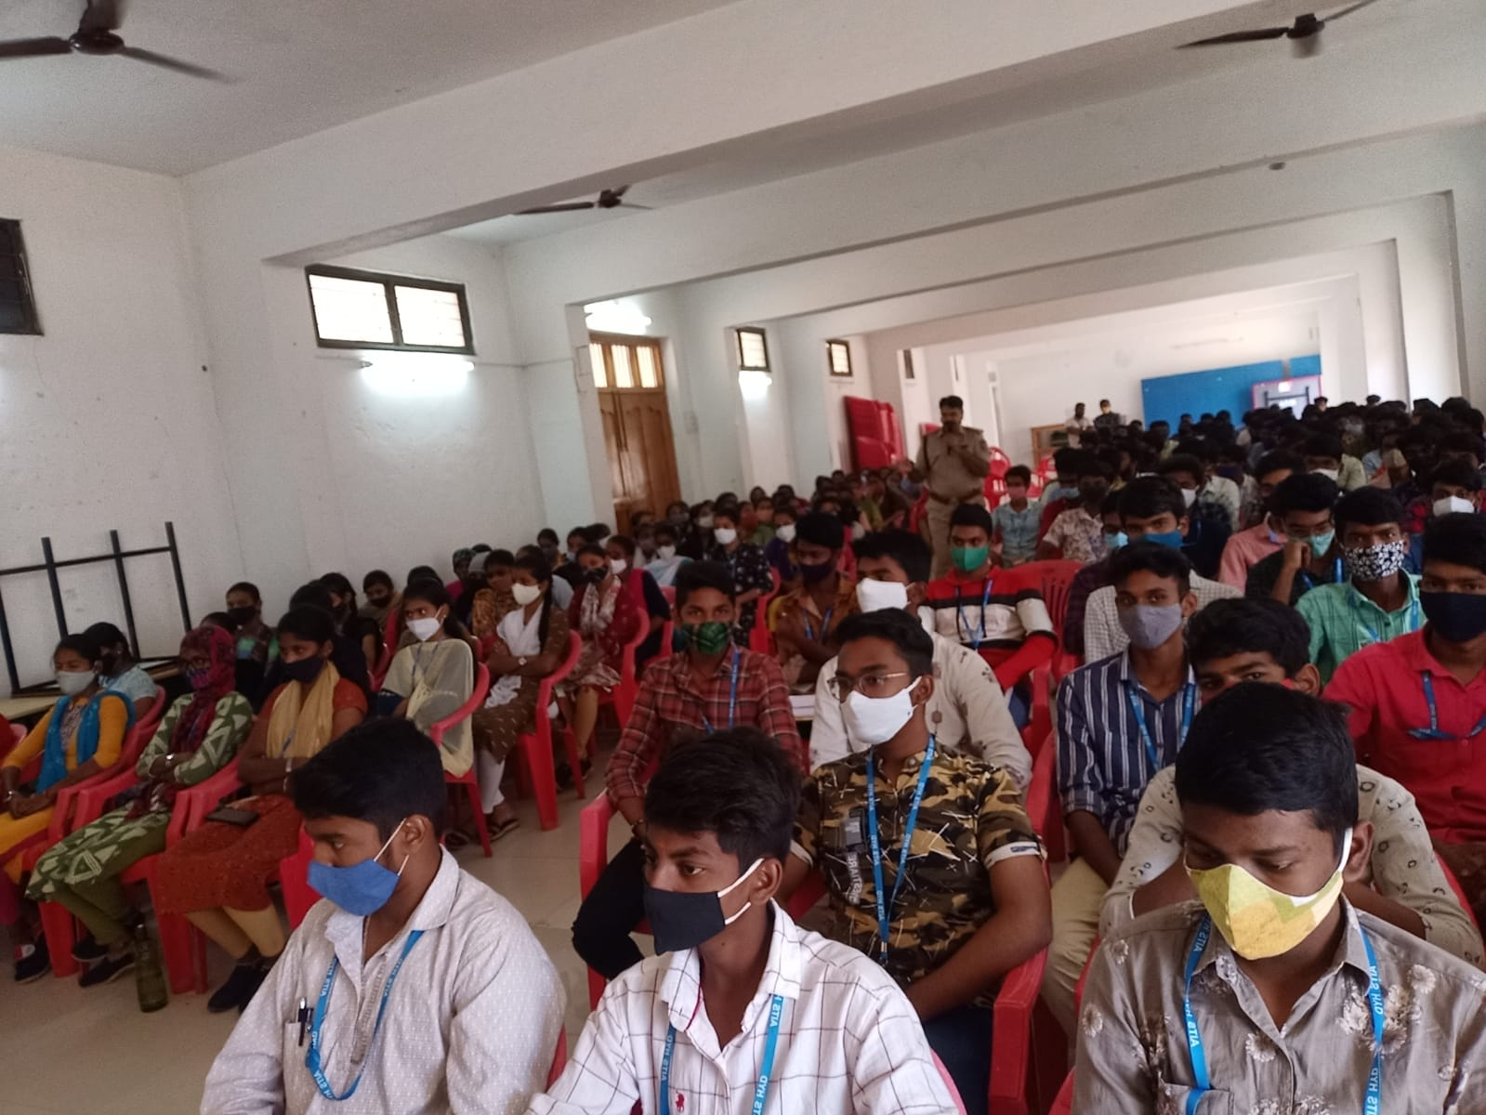

**She Team organized at AITH (She Team) members addressed the gathering for girls and Boys students.**



**She Team S.I addressed the girl and Boys students to mould themselves in all aspects of their life.**

**7. Yoga**

Yoga is a mind and body practice. Various styles of yoga combine physical postures, breathing techniques, and meditation or relaxation. Yoga is an ancient practice that involves physical poses, concentration, and deep breathing. Yoga offers flexibility to the body and relaxation to the mind. There are different asanas practised by people, and each asana has its benefits on the mind and body. Yoga is designed to sharpen our minds and to improve our intelligence. Regular practice of yoga can help in controlling our emotions and promote well-being.

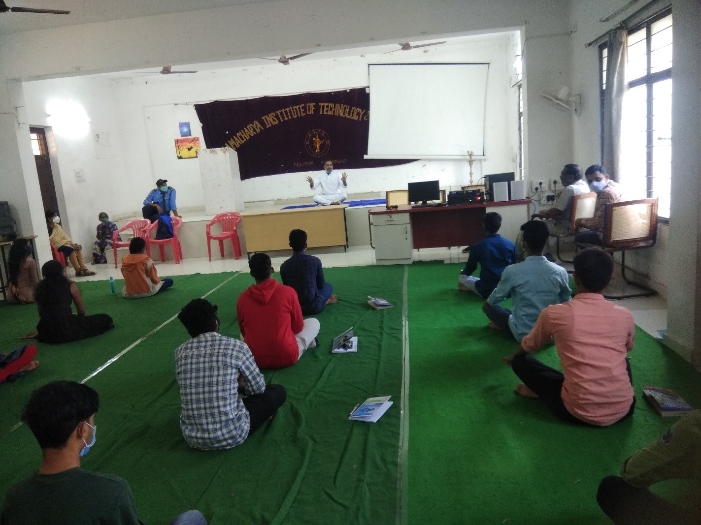**AITH conducting Yoga sessions to improve student’s will-power they can achieve their goals easily.**



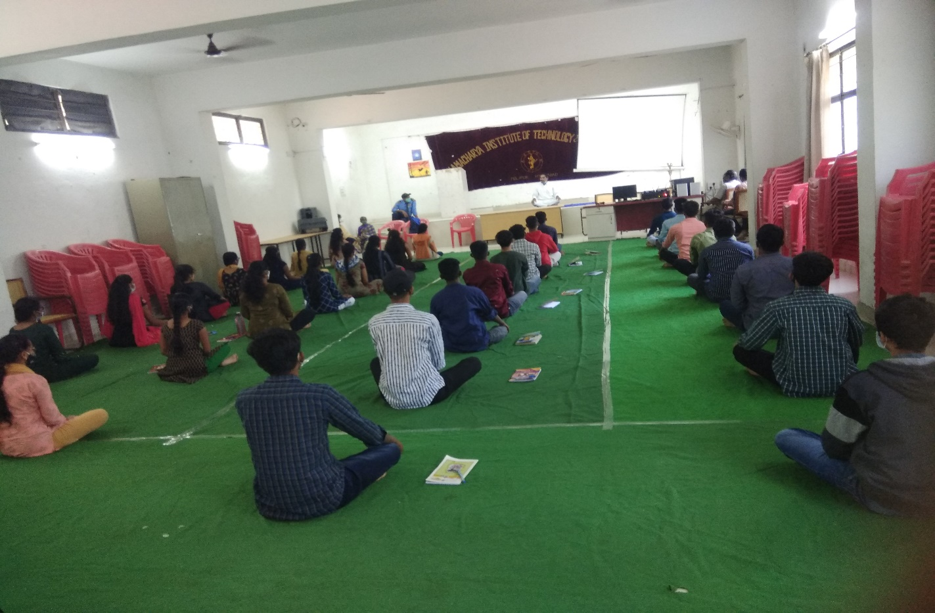**Yoga performed by students in AITH campus**

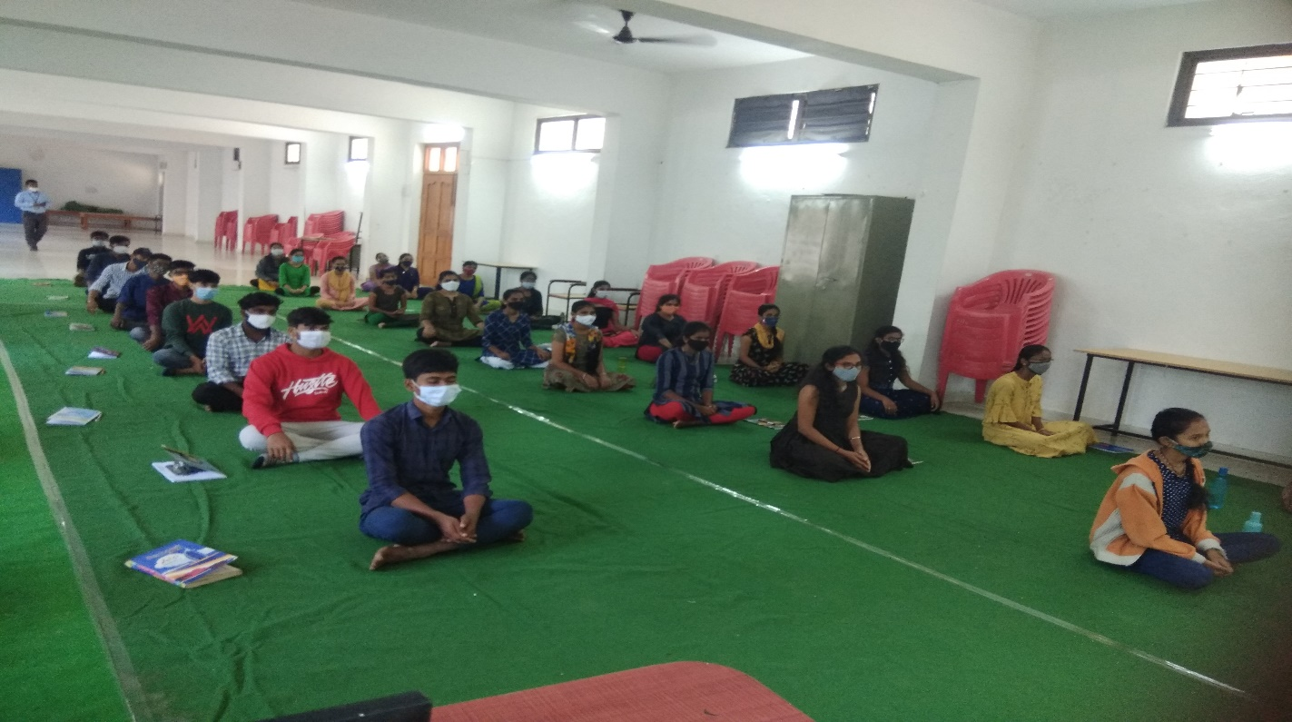**Yoga performed by girl students in AITH campus**

**8. Sports:**

Sport has the power to change lives. The ability to drive gender equality by teaching women and girls teamwork, self-reliance, resilience and confidence. Women in sport defy gender stereotypes and social norms, make inspiring role models, and show men and women as equals. Helps maintain healthy bones, muscles, and joints. Helps control weight, build lean muscle, and reduce body fat. AITH sports club play a significant role in helping the girl students improve their sports and physical fitness. AITH conducting common sports remove the barrier between gender.

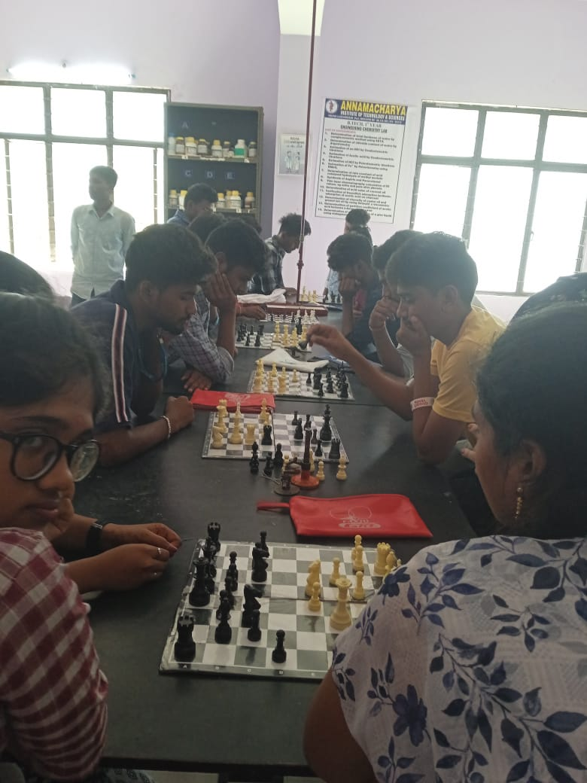

**Sports Day Celebrations at AITH**

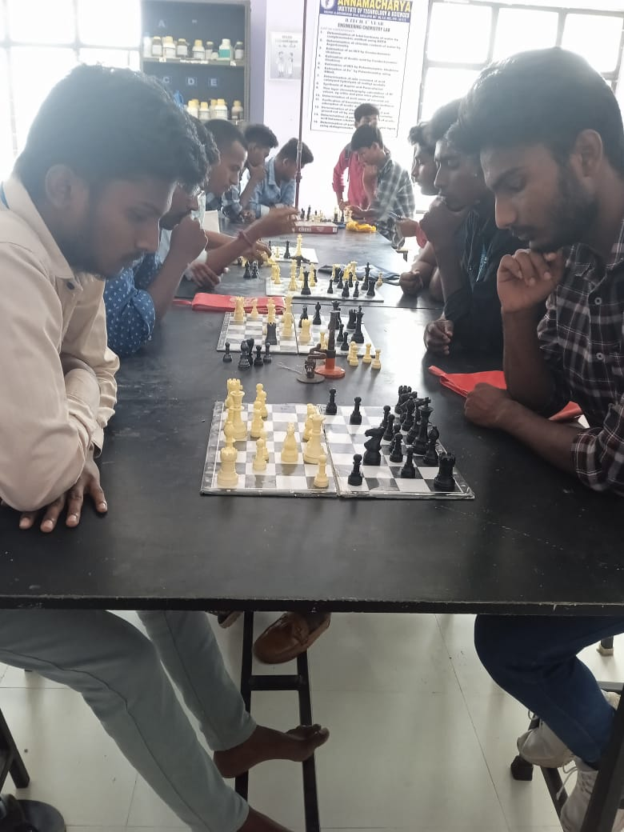

**Sports Day Celebrations at AITH**

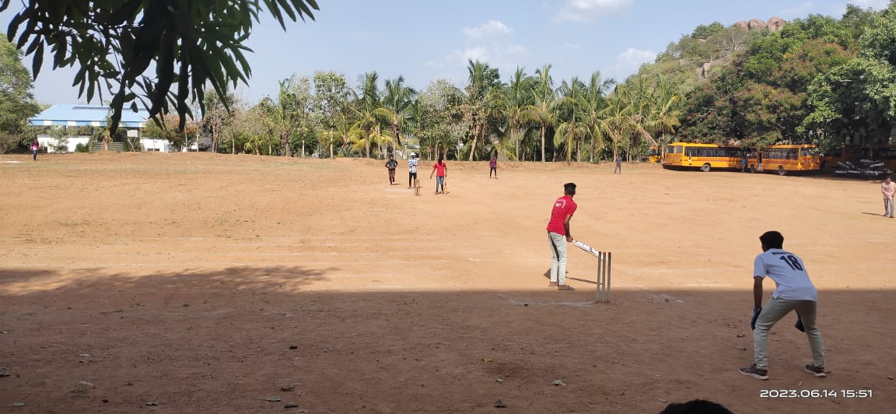**AITH conducted Sports for the faculty and Students**

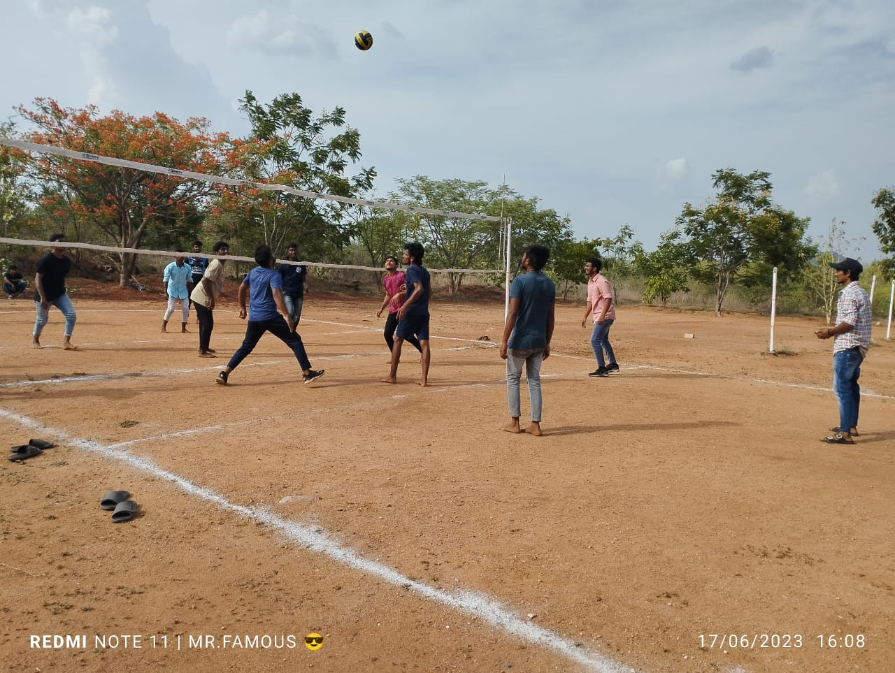**ATIH organized Sports (Throw Ball) for the students**



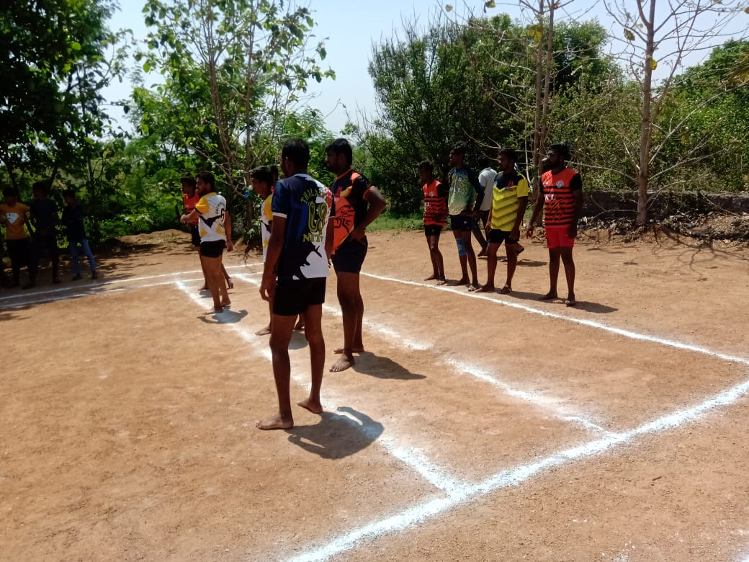 **AITH Organized Sports (Kabadi) for the faculty.**

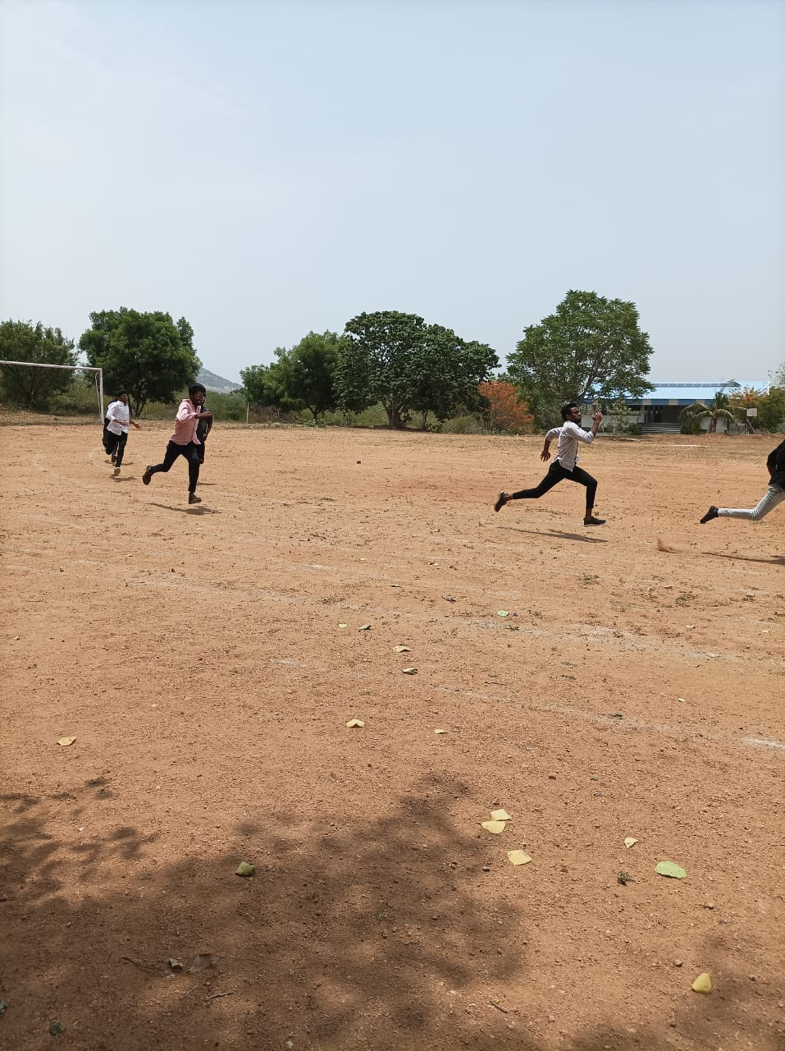**AITH organized Sports (Running) for the Students.**

**9. Rangoli Competitions:**

# Keeping in view to students’ appetite for activities apart from academics, we keep them occupied with various extra-curricular cultural Activities like Rangoli Competitions. Rangoli Competitions are organized in the institution to enhance creativity and unleash the hidden potential of the students. Students made Rangolis and presented beautiful designs.

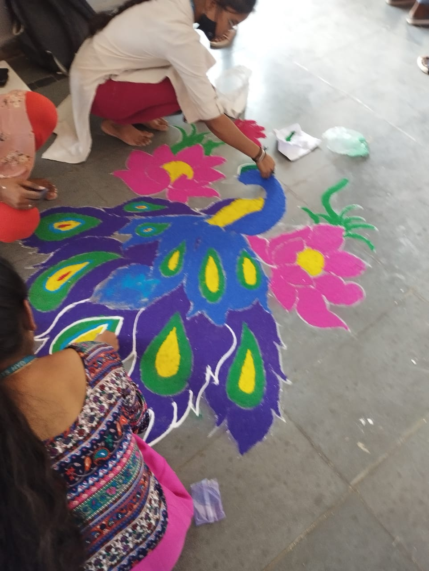**Rangoli Celebrations for the Girl students**

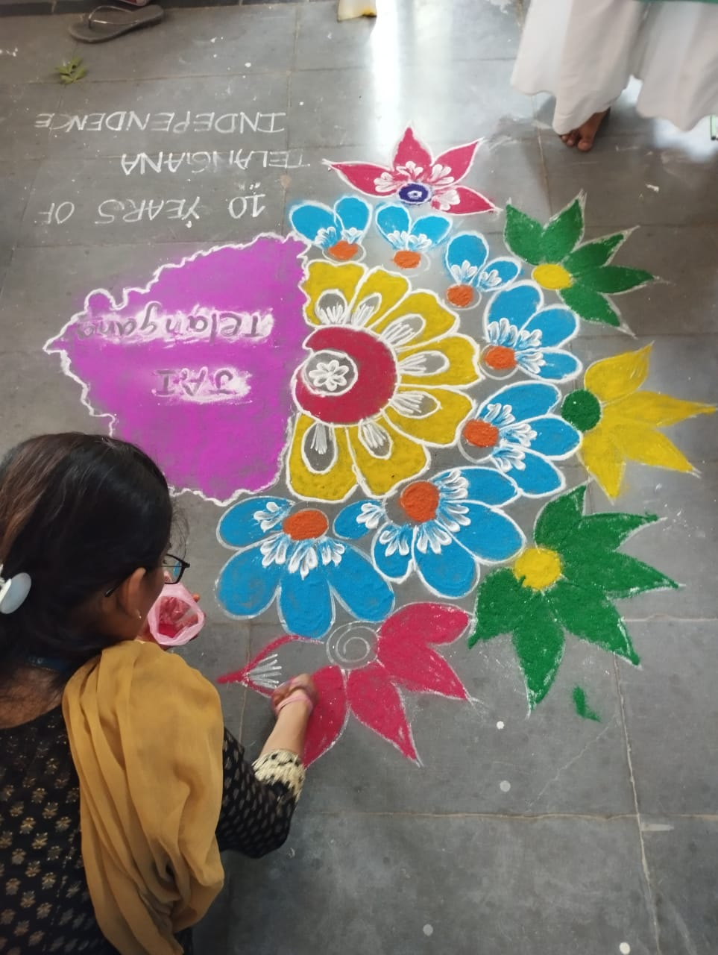**Rangoli Celebrations for the Lady faculty**

# C:\Users\cse\Desktop\PHOTOS\Sports and Rangoli\Ragoli\IMG-20230621-WA0011.jpg

# Rangoli Celebrations for the Girl students

# C:\Users\cse\Desktop\PHOTOS\Sports and Rangoli\Ragoli\IMG-20230621-WA0019.jpg

# C:\Users\cse\Desktop\Sign pvkm1.jpgRangoli Celebrations for the Girl students

**10. Women Welfare committee:**

The main objective of the committee is to motivate, empower women and secure feminine gender. It aims to prevent sexual harassment and to promote general well-being of female students, teaching and non-teaching women staff of the college. Women Welfare committee has organized seminars on Women Welfare Laws, women trafficking, violence at home, self-development.

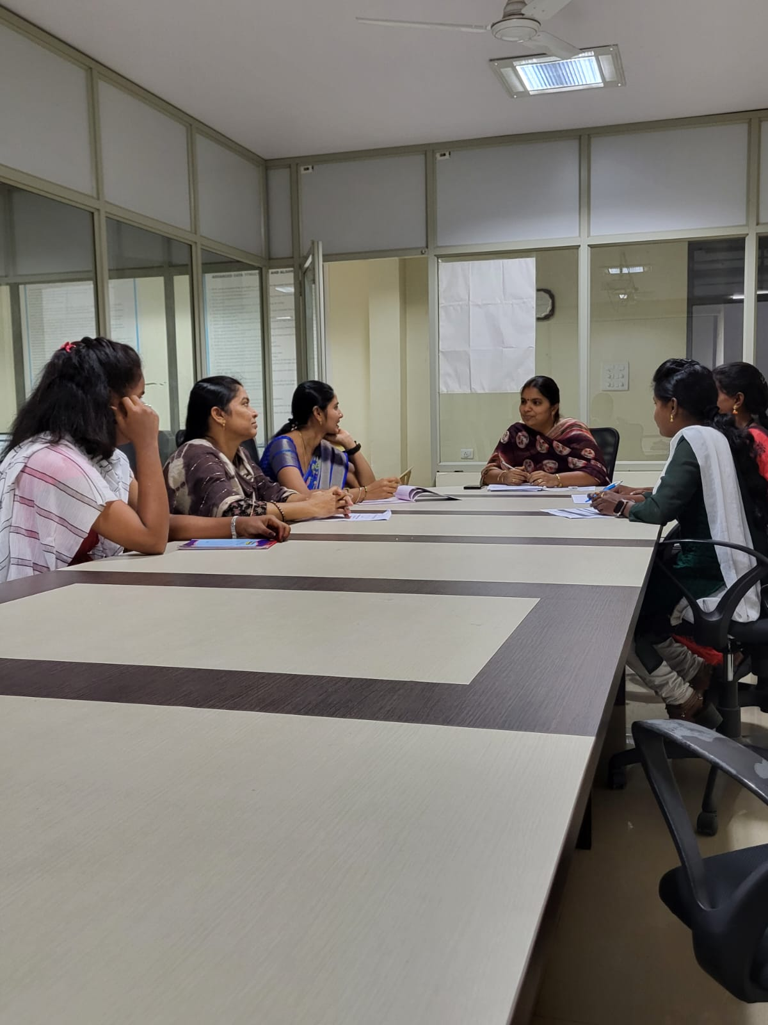**Women Empowerment and social responsibilities in gender perspective by K Naga Latha.**



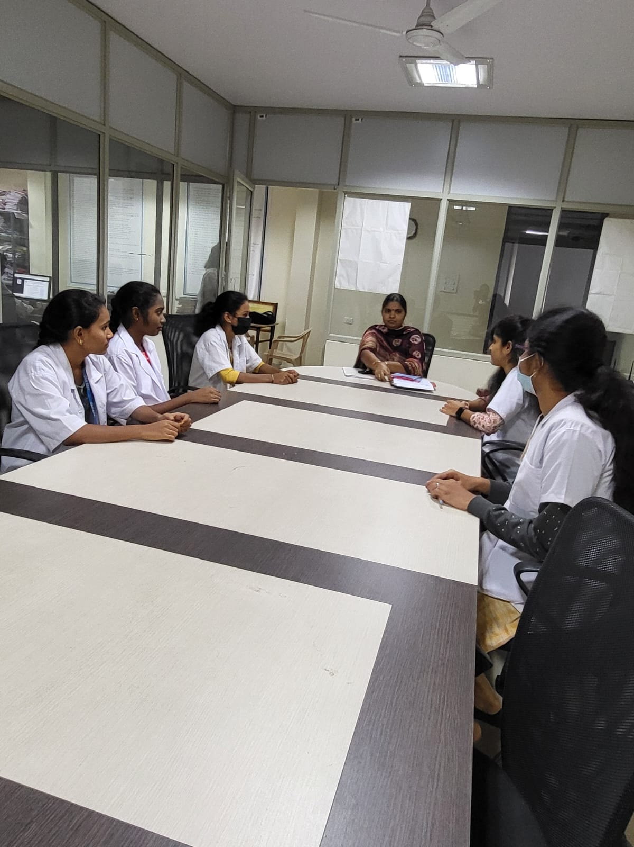

**Women Empowerment and social responsibilities in gender perspective for students counselling by K Naga Latha Madam**



## **11. Technical Symposium for Girls:**

The Institute has conducted the Technical Symposium for Boys & Girls students separately every year. They have been encouraged to even participate in other intuitions / organizations. In this event we conduct paper presentation, Technical Quiz, seminars and poster presentations.

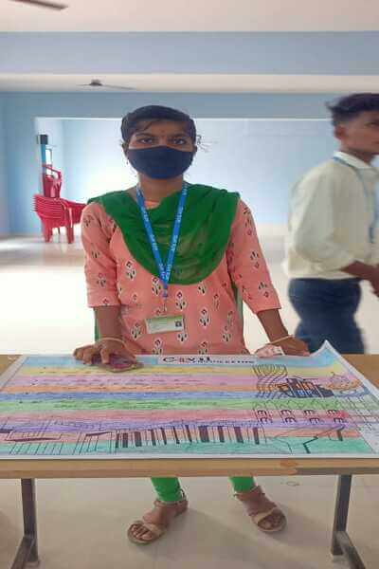

**Poster presentations by Anivitha**

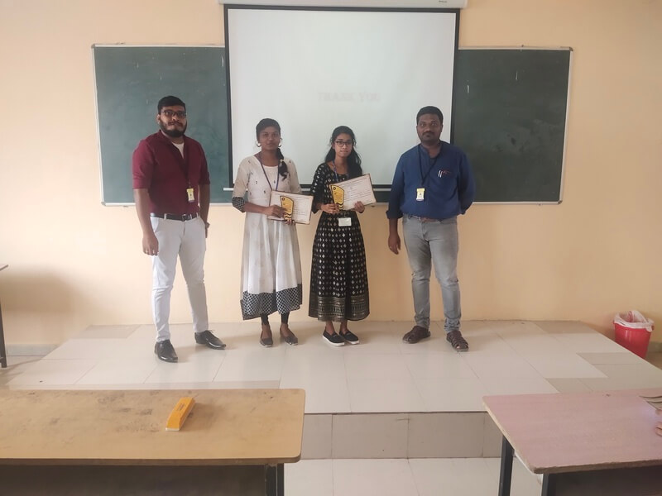

**AITH Organized seminars and awarded prizes for the students.**

**12. International women's day:**

International Women's Day is an occasion to celebrate the progress made towards achieving gender equality and women's empowerment but also to critically reflect on those accomplishments and strive for a greater momentum towards gender equality worldwide. AITH celebrates International Women's Day to empower women with motivational talk on self-confidence, decision making and their rights in all aspects.

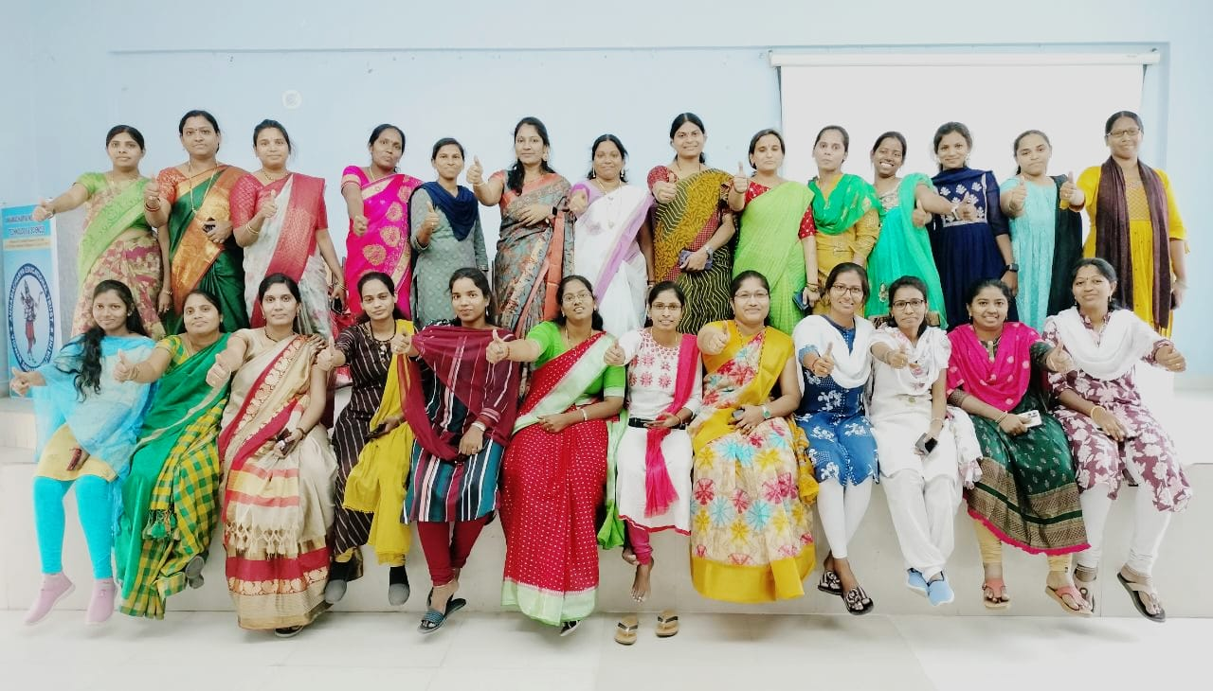**Women’s Day Celebration on 08/03/2022**



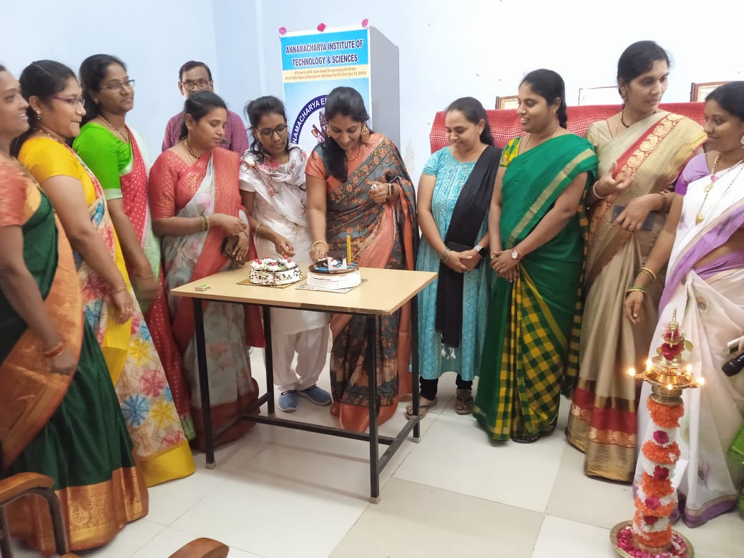**Women’s Day Celebration on 08/03/2022 with Management, Staff at AITH**

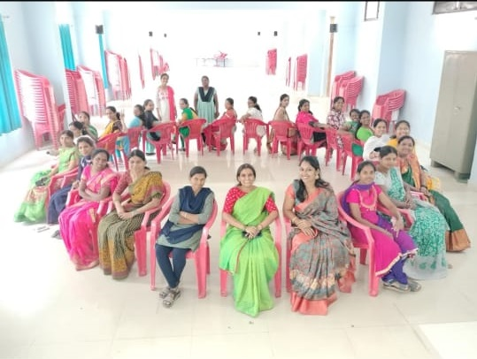 **Musical chairs for woman on International Women’s day at AITH**

**13. Annual Gender Sensitization Action Plan for last five years**

**2022-2023**

|  |  |  |
| --- | --- | --- |
| **S.NO** | **EVENT** | **Date** |
| 1 | Gender Equity | 13-09-2022 |
| 2 | Yoga Day | 21-09-2022 |
| 3 | Self defence and Karate Programme | 04-10-2022 |
| 4 | Bhathukamma celebrations | 12-10-2022 |
| 5 | Faculty Sports Day | 31-10-2022 |
| 6 | Anti-Drug Awaarness Program | 10-10-2022 |
| 7 | She Teams | 22-11-2022 |
| 8 | Self-Development | 09-12-2022 |
| 9 | Women Empowerment | 03-01-2023 |
| 10 | Rangoli competition | 07-01-2023 |
| 11 | International Women's Day 2023 | 08-03-2023 |
| 12 | Mehendi Celebrations | 06-04-2023 |
| 13 | Technical Symposium | 11-05-2022 |

**2021-2022**

|  |  |  |
| --- | --- | --- |
| **S.NO** | **EVENT** | **Date** |
| 1 | Gender Equity | 04-09-2021 |
| 2 | Yoga Day | 25-09-2021 |
| 3 | Self defence and Karate Programme | 06-10-2021 |
| 4 | Bhathukamma celebrations | 19-10-2021 |
| 5 | Faculty Sports Day | 29-10-2021 |
| 6 | She Teams | 19-11-2021 |
| 7 | Self-Development | 21-12-2021 |
| 8 | Women Empowerment | 05-01-2022 |
| 9 | Rangoli competition | 12-01-2022 |
| 10 | Mehendi Celebrations | 04-03-2022 |
| 11 | International Women's Day 2022 | 08-03-2022 |



**2020-2021**

|  |  |  |
| --- | --- | --- |
| **S.NO** | **EVENT** | **Date** |
| 1 | Gender Equity | 10-07-2020 |
| 2 | Self defence and Karate Programme | 20-07-2020 |
| 3 | Yoga Day | 08-09-2020 |
| 4 | She Teams | 24-09-2020 |
| 5 | Bhathukamma celebrations | 05-10-2020 |
| 6 | Faculty Sports Day | 09-11-2020 |
| 7 | Self-Development | 28-12-2020 |
| 8 | Rangoli competition | 11-01-2021 |
| 9 | Mehendi Celebrations | 06-03-2021 |
| 10 | International Women's Day 2021 | 08-03-2021 |

**2019-2020**

|  |  |  |
| --- | --- | --- |
| **S.NO** | **EVENT** | **Date** |
| 1 | Yoga Day | 21-06-2019 |
| 2 | Gender Equity | 25-07-2019 |
| 3 | She Teams | 05-08-2019 |
| 4 | Bhathukamma celebrations | 12-10-2019 |
| 5 | Rangoli competition | 10-01-2020 |
| 6 | Self-Development | 31-01-2020 |
| 7 | Faculty Sports Day | 08-02-2020 |
| 8 | Mehendi Celebrations | 07-03-2020 |
| 9 | International Women's Day 2020 | 08-03-2020 |



**2018-2019**

|  |  |  |
| --- | --- | --- |
| **S.NO** | **EVENT** | **Date** |
| 1 | Yoga Day | 22-06-2018 |
| 2 | Self-Development | 13-07-2018 |
| 3 | Bhathukamma celebrations | 20-09-2018 |
| 4 | Rangoli competition | 10-01-2019 |
| 5 | Faculty Sports Day | 30-01-2019 |
| 6 | Gender Equity | 28-02-2019 |
| 7 | Mehendi Celebrations | 07-03-2019 |
| 8 | International Women's Day 2019 | 08-03-2019 |

