

ANNAMACHARYA INSTITUTE OF TECHNOLOGY AND SCIENCE
Piglipur, Batasingaram, Hayathnagar(M), R.R.Dist-501512

Institution has performance Appraisal System for Teaching and Non-Teaching Staff

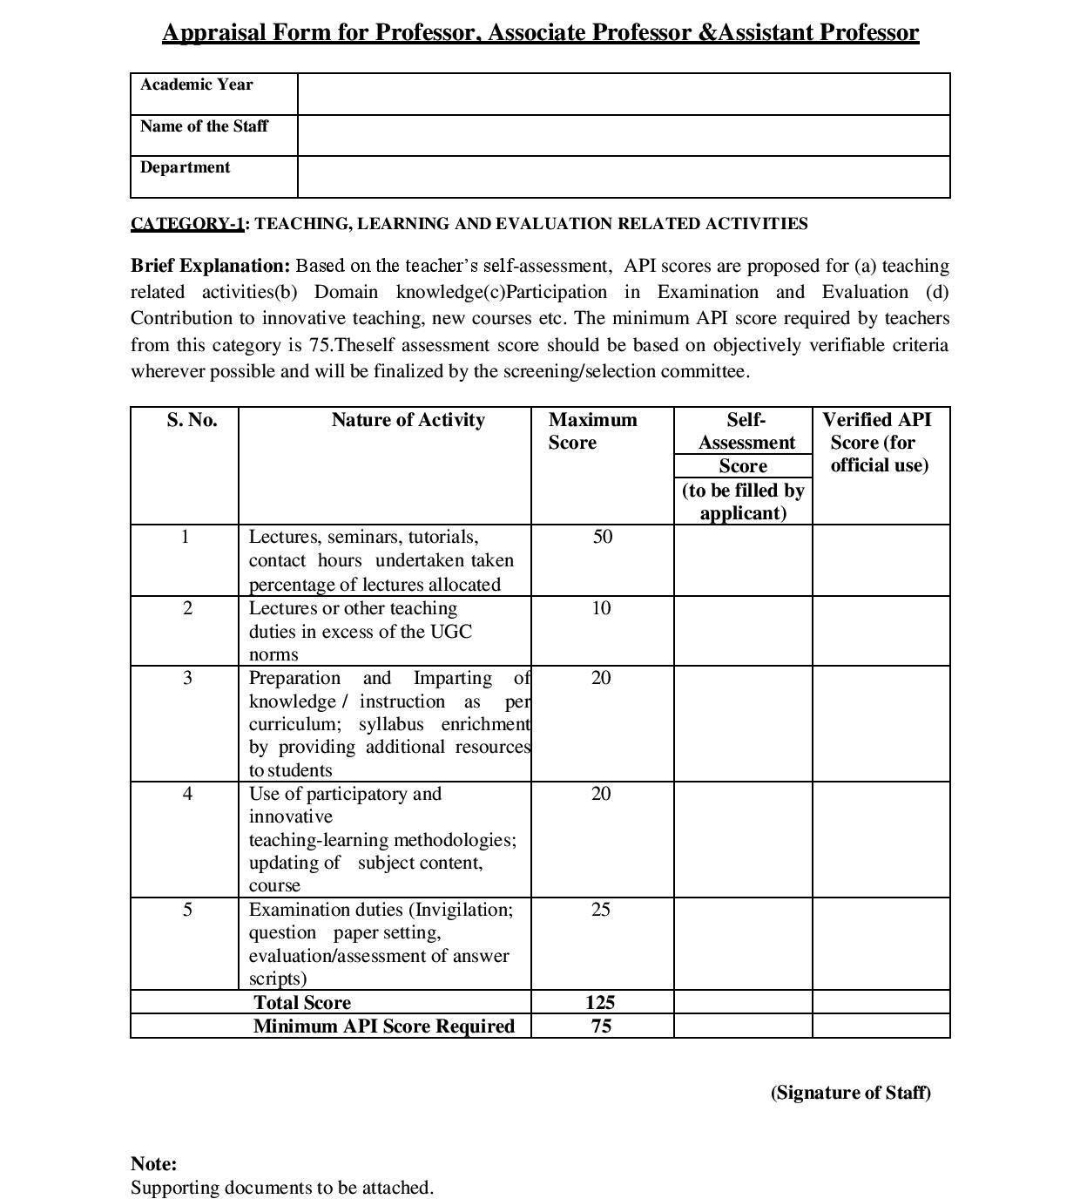
ANNAMACHARYA INSTITUTE OF TECHNOLOGY AND SCIENCE
Piglipur, Batasingaram, Hayathnagar(M), R.R.Dist-501512

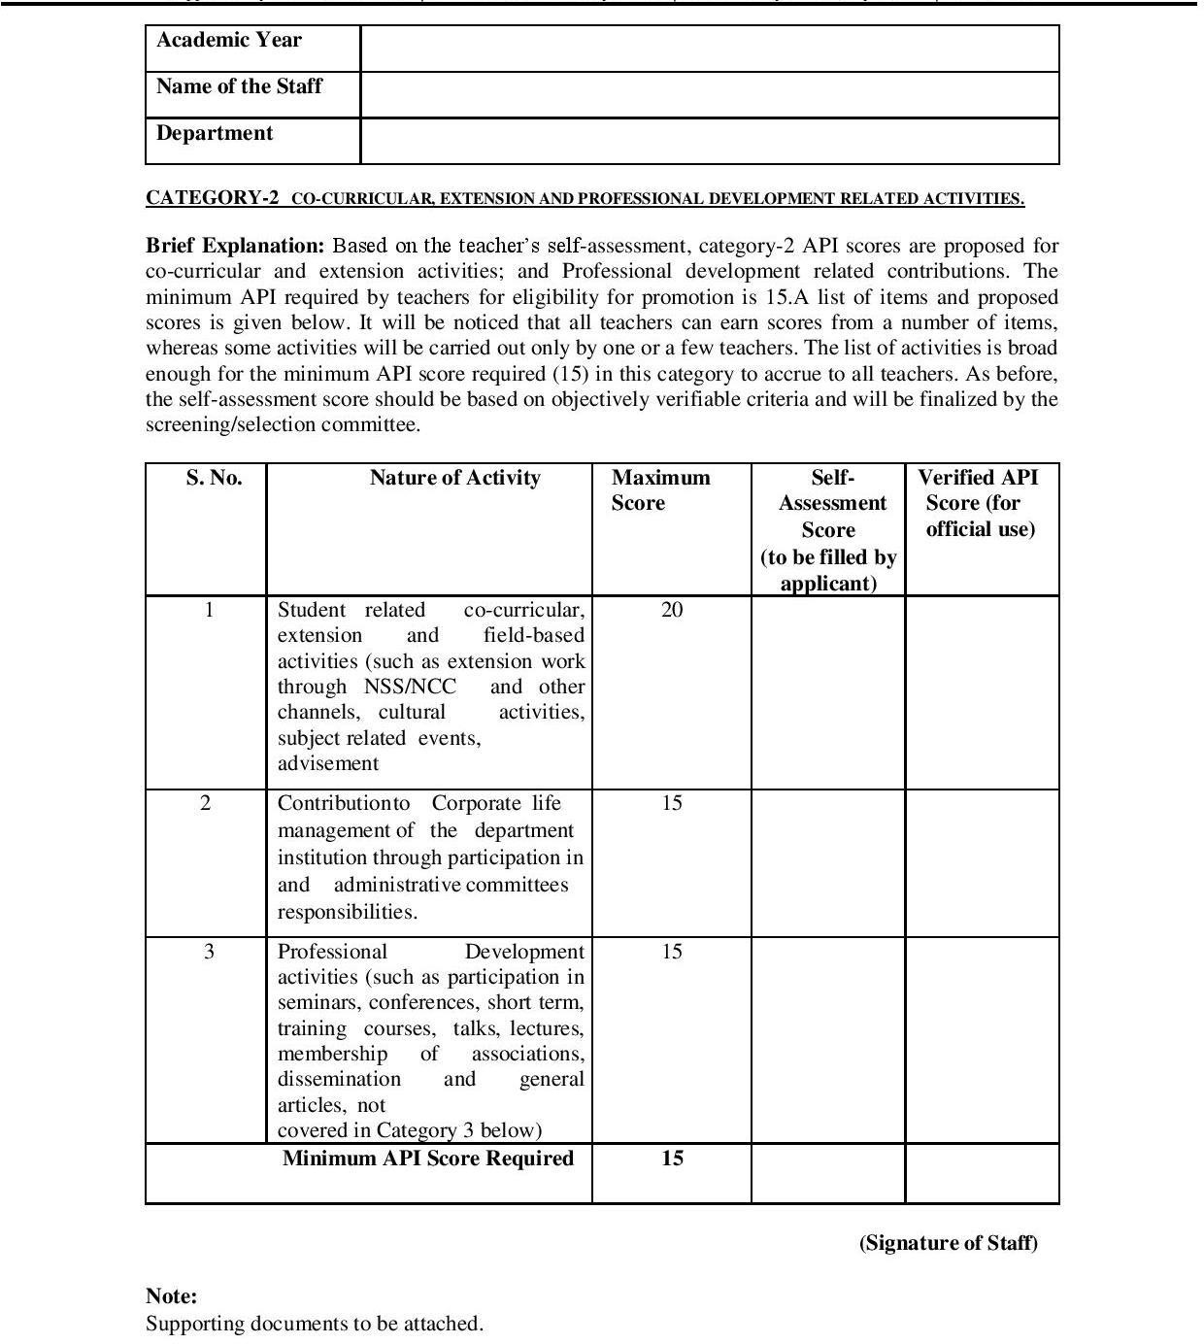
ANNAMACHARYA INSTITUTE OF TECHNOLOGY AND SCIENCE
Piglipur, Batasingaram, Hayathnagar(M), R.R.Dist-501512

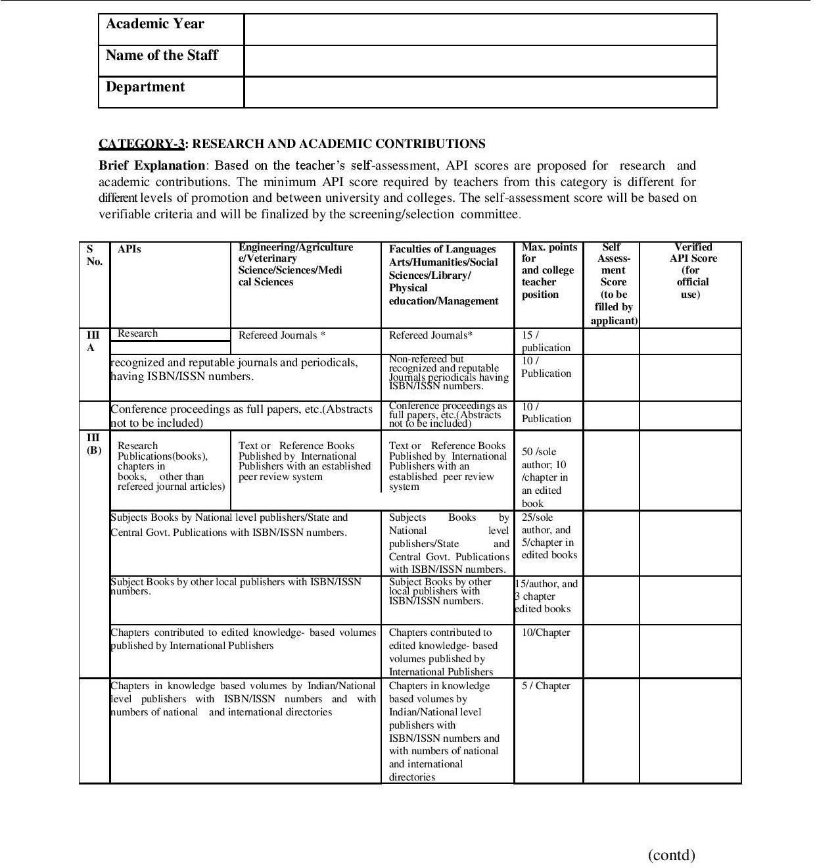

ANNAMACHARYA INSTITUTE OF TECHNOLOGY AND SCIENCE
Piglipur, Batasingaram, Hayathnagar(M), R.R.Dist-501512

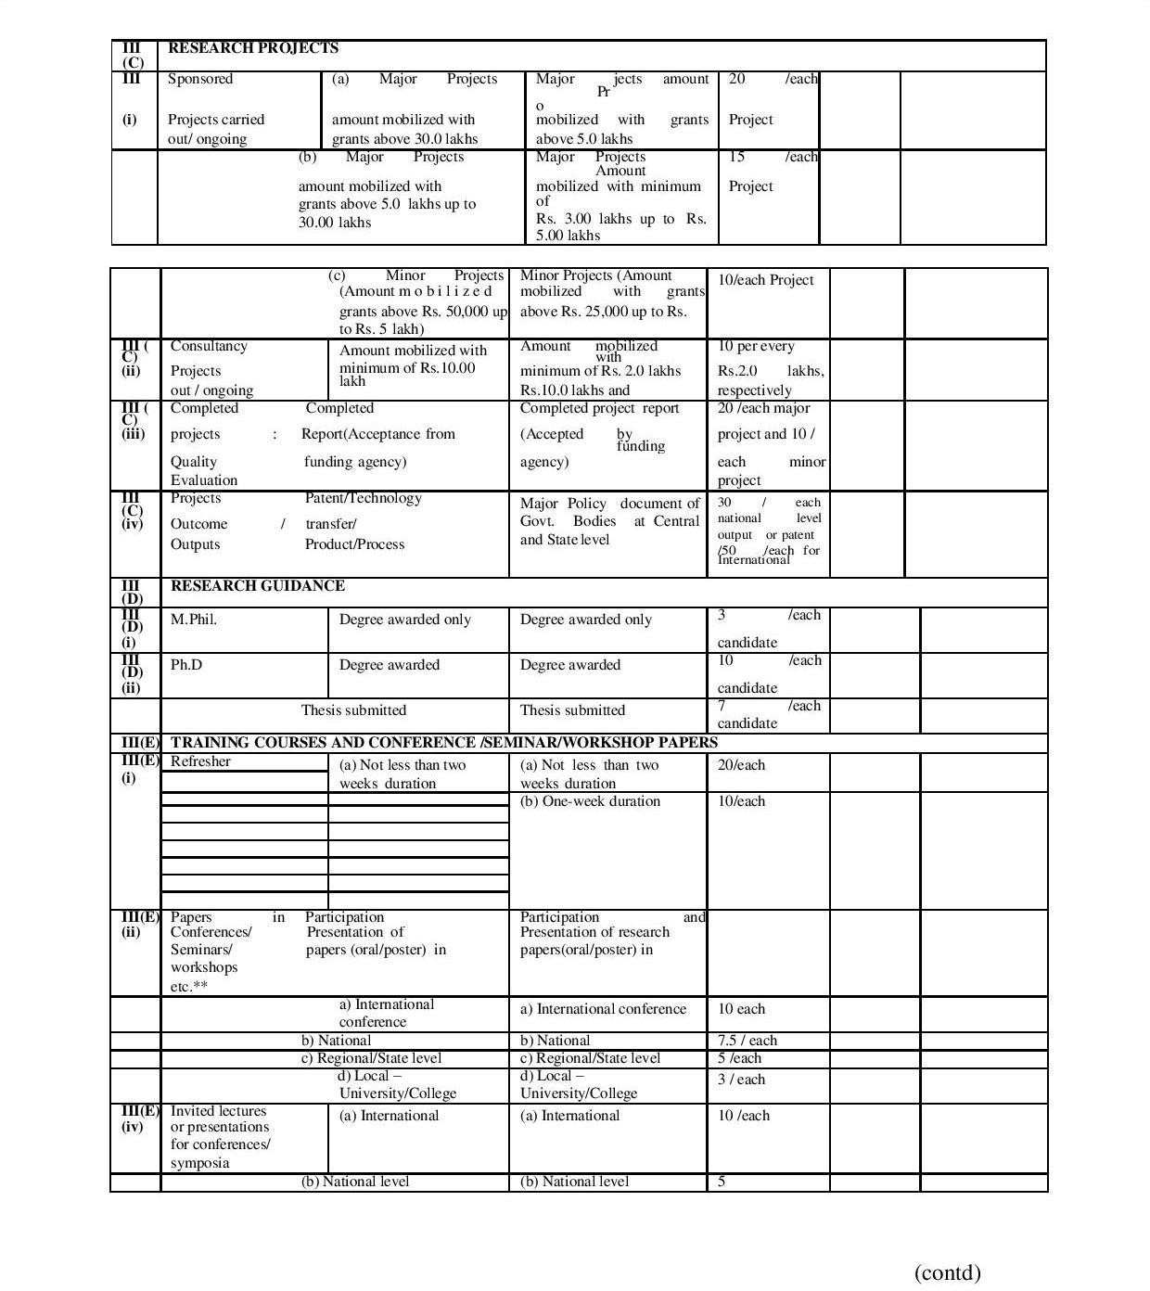
ANNAMACHARYA INSTITUTE OF TECHNOLOGY AND SCIENCE
Piglipur, Batasingaram, Hayathnagar(M), R.R.Dist-501512

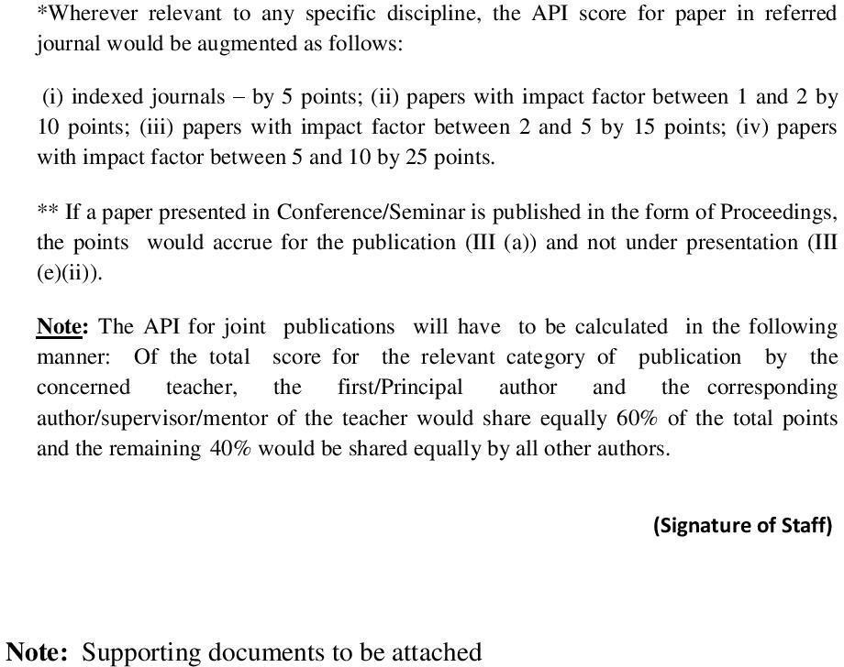
ANNAMACHARYA INSTITUTE OF TECHNOLOGY AND SCIENCE
Piglipur, Batasingaram, Hayathnagar(M), R.R.Dist-501512

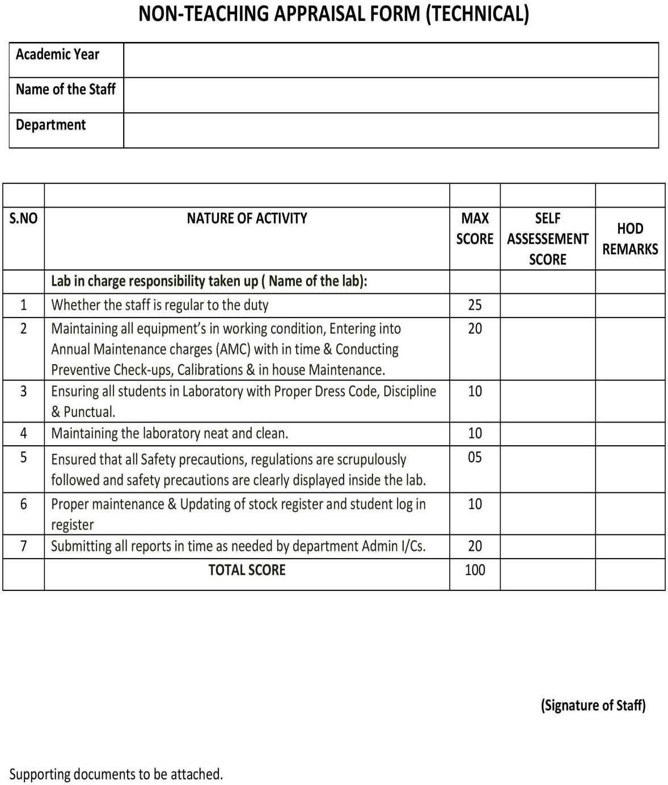

ANNAMACHARYA INSTITUTE OF TECHNOLOGY AND SCIENCE
Piglipur, Batasingaram, Hayathnagar(M), R.R.Dist-501512

